19

19 .1 - ওয়ার্ডপ্রেসের ভিজ্যুয়াল এডিটরে (TinyMCE) নতুন বাটন

Amra aga ayi picture dekha ayi shob add korbo:

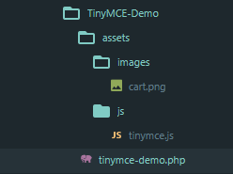

Diya amra tinymce-demo.php ta giya prothoma amra akta action hook add korbo r ar vitora amra, tai amra akta add_action() banachi, r attar $tag hoba ‘admin_init’ r $function_to_add hoba ‘tmcd_admin_assets’ . Akun amra tmcd_admin_assets function ta banabo. Function_body vitora amra 2 ta filter hook add korbo, 1st filter hook a amra $tag hishaba amra ‘mce_external_plugins’ dibo r $function_to_add a amra ‘tmcd_mce_external_plugins’. 2nd filter hook a amra $tag hisaba amra ‘mce_buttons’ r ‘tmcd_mce_buttons’ dibo. Akun amra 2nd filter hook a $tag hishaba ‘mce_buttons’ hoba ar $function_to_add a ‘tmcd_mce_buttons’ hoba.

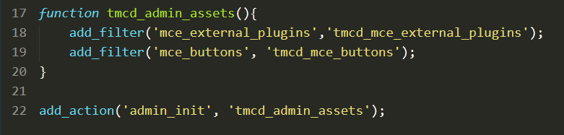

Amra akun tmcd_mce_button function banabo ar parameterlist hisaba $buttons nibo. Function_body ta amra $buttons[] nama array nibo r ‘tmcd_button_one’ string ta assign korbo oyi $buttons[] a. Next step amra return $buttons dibo.

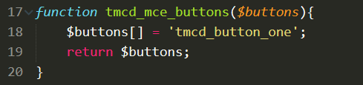

Akun amra tmcd_mce_external_plugins function banabo. Ayi function ta bananor main goal hocha ta amader js folder tinymce.js file ta ka locate korai ditta hoba. Akun amra ayi function a, $plugins naam a akta parameterlist add korbo. Ayi $plugins variable ka amra akun associated array banabo, r ‘tmcd_plugin’ ka oyi array index hisaba dibo. wp_enqueue_script('tinymce.js', plugin_dir_url(__FILE__)."assets/js/tinymce.js") assign kori amra oyi associated array ka. Next step a amra return plugins; dibo.

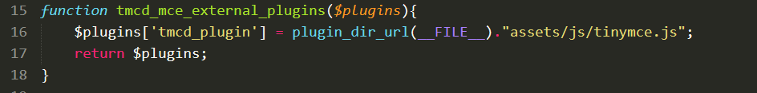

Tarpor amra tinymce.js file giya

alert(‘loaded’);

code ta add korbo. Tarpor amra browser giya post edit click kora

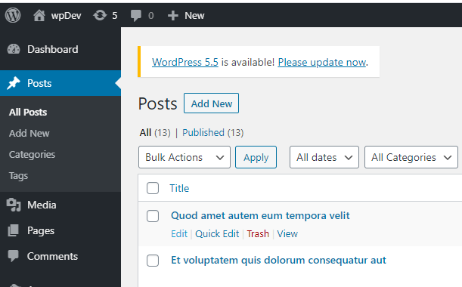

Diya amra visual a click kora amra alert message pabo

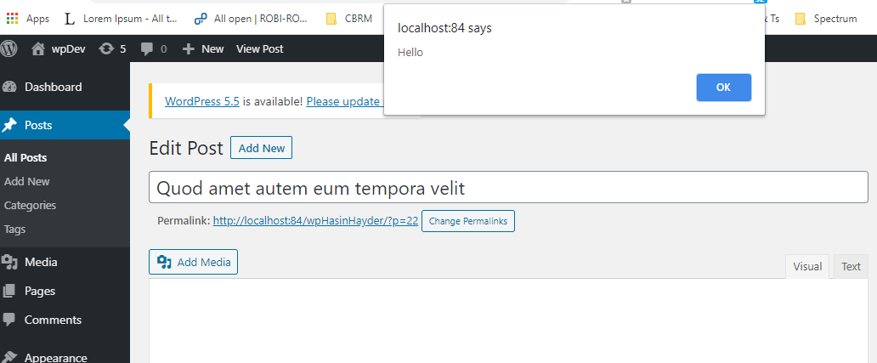

Note: Visual ta jano click korta hoba taholla ache alert

check korbo ja otta alert message asche. Akun amra oyi alert(‘loaded’); remove korbo ar IIFE(Immediately-Invoked Function Expression) diya otter function body ta amra tinyMCE.PluginManager.add(). Ar add() vitora ‘tmcd_plugin’ ar akta function add korbo parameterlist hisaba. Ayi function ar konno name hoba na, r editor & url 2ta parameterlist hisaba jaba. Tarpor amra function body ta amra editor ar addButton method ta access korbo. Ayi addButton amra ‘tmcd_button_one’ ar akta object initialize korbo {text:’B1’}. Tai overall code hobe

;(function(){

tinyMCE.PluginManager.add('tmcd_plugin',function(editor, url){

editor.addButton('tmcd_button_one',{

'text':'B1'

});

});

})();

Akun amra oyi edit page refresh kora dekhi ja B1 button cholla ascha

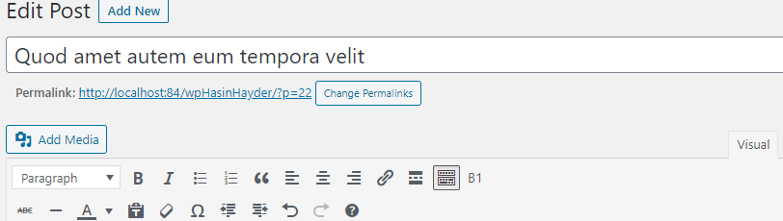

Kintu click korla kichu hocha na attar jonno abar agar js code giya amra atta code set korbo ayi khana

;(function(){

tinyMCE.PluginManager.add('tmcd_plugin',function(editor, url){

editor.addButton('tmcd_button_one',{

‘text’:'B1',

change kora atta hoba

onclick:function(){

alert('Hello');

}

});

});

})();

text:'B1',

Tarpor amra akun button click kora dekbo

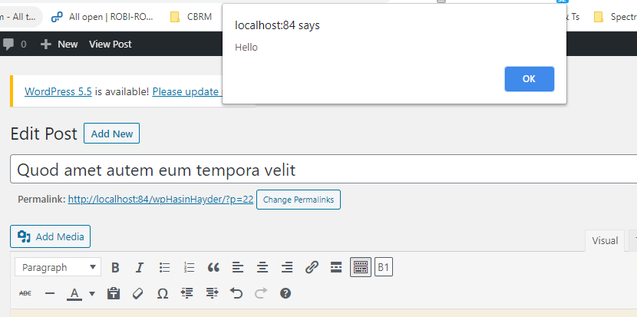

Amra akun jodi editor konno kaj korta jai taholla editor.insertContent() use korta hoba tai akun tinymce.js a giya amra ayi onclick funciton code a amra

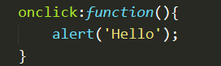

editor.insertContent("Hello World");

akhun jodi amra browser check kori editor a amra mouse ka ak jaigai mouse ka amra click kora B1 button ta press kori taholla amra Hello World pabo

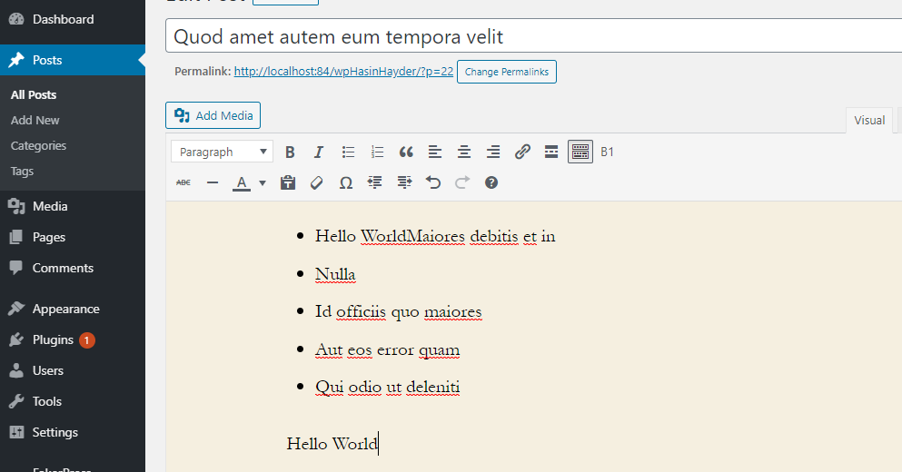

Akun amra ayi editor.insertContent a akta shortcode add korbo, tai

editor.insertContent("Hello World ");

change

[gmap]content[/gmap]

Akun jodi browser abar B1 button a click kori taholla shortcode ta asba.

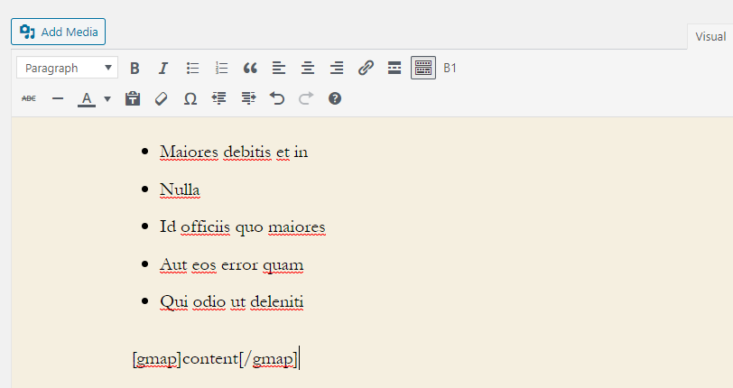

atta dekhaba

atta click korla

Akun jodi amra icon add korta chai button a taholla shudhu akta nothun key r value add korbo object ar vitora r amra jodi text ta ka off kora di

;(function(){

tinyMCE.PluginManager.add('tmcd_plugin',function(editor, url){

editor.addButton('tmcd_button_one',{

//text:'B1',

icon:'insertdatetime',

onclick:function(){

editor.insertContent("[gmap]content[/gmap]");

}

});

});

})();

Taholla amra B1 button ta ka icon hishaba dekta parbo browser a



Amra ayi akhanna akun image dibo, to amra icon key ta ka comment kora akhun image key ta dibo ar otter value hisabe amra url+”/../images/cart.png”, dibo

akun jodi amra refresh kori taholla amra dekta parbo cart image ta

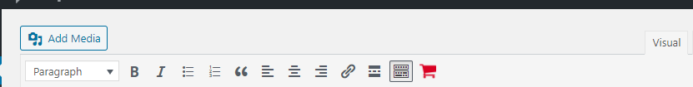

19.2

Amra akun akta list box add korta chai. Attar jonno amra ‘tmcd_listbox_one’ atka new item hishaba $buttons[] ka append korchi tmcd_mce_buttons method body vitora tinymce-demo.php page a . Akun amra tinymce.js giya agar editor.addButton method paste kora ottar 1st parameter change kora dibo r naam dibo ‘tmcd_listbox_one’. 2nd parameter jeta hocha object literal or vitora amra keyword type add korbo r value hishaba amra ‘listbox’ dibo. text keyword ar value ta change kora dibo amra ‘Select Something’. value naam a akta keyword add korbo r attar value hoba akta array jar vitor amra json add korbo. Oyi json gullo hoba :

1. {text:'Apple', value:'You have selected <b>Apple</b>'},
2. {text:'Orange', value:'You have selected <em>Orange</em>'},
3. {text:'Banana', value:'You have selected <u>Apple</u>'}

PTO

Tai overall code hoba:

editor.addButton('tmcd_listbox_one',{

type:'listbox',

text:'Select Something',

values: [

{text:'Apple', value:'You have selected <b>Apple</b>'},

{text:'Orange', value:'You have selected <em>Orange</em>'},

{text:'Banana', value:'You have selected <u>Banana</u>'}

],

onselect:function(){

editor.insertContent(this.value())

}

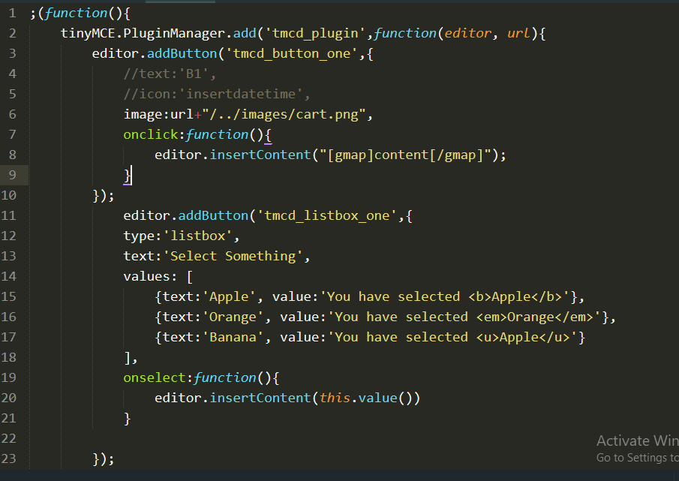

Tarpor amra browser giya amra tokhun akta post edit button click kora oyi page giya amra visual click kora amra dekta parbo dropdown ta

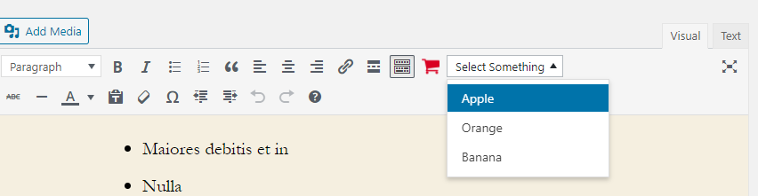

Akun jodi akta select kori jamon Orange taholla amra ottar value dekta parbo

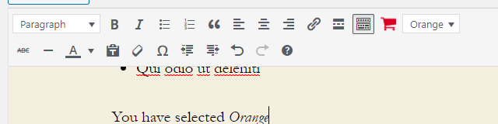

After selecting we get the value

Akun amra chabo ja prothoma akta value selected thakuk attar jonno amra tokhun oyi object literal a giya onPostRender keyword ta add korbo r attar value hoba akta function jetar function_body ta amra this.value('You have selected <u>Banana</u>’); add korbo. Tai overall code hoba:

onPostRender:function(){

this.value('You have selected <u>Banana</u>');

}

Ayi ja Banana set kora acha



19.3

Akun amra multi level ar dropdown menu add korbo. Aga amra tinymce-demo.php ta giya amra function tmcd_mce_buttons ar function body ta amra ‘tmcd_menu_one’ nothun value add korbo $buttons[] array ta. Tarpor amra tinymce.js ta giya amra nothun editor.addButton method add korbo (agar ta copy r paste kora) . Ayi nothun editor.addButton er 1st parameter ta change kora amra naam dibo 'tmcd_menu_one' r object literal vitora amra type keyword er value ‘menubutton’ dibo . text keyword ar value ta ami dibo ‘Choices’. tarpor amra nothun keyword add korbo r naam dibo menu jetar value atka array hoba. R ayi array ta amra json object pass porbo. R ayi json menu hocha:

{

text:"Option A",

onclick:function(){

console.log('Option A');

}

},

{

text:"Option B",

onclick:function(){

console.log('Option B');

}

},

{

text:"Option C",

onclick:function(){

console.log('Option C');

}

}

So overall code ta hoba:

editor.addButton('tmcd_menu_one',{

type:'menubutton',

text:'Choices',

menu:[

{

text:"Option A",

onclick:function(){

console.log('Option A');

}

},

{

text:"Option B",

onclick:function(){

console.log('Option B');

}

},

{

text:"Option C",

onclick:function(){

console.log('Option C');

}

}

]

});

Tarpor save kora amra browser check korbo ja Choices naam akta dropdown menu asche r attar click korla console Output dekhai

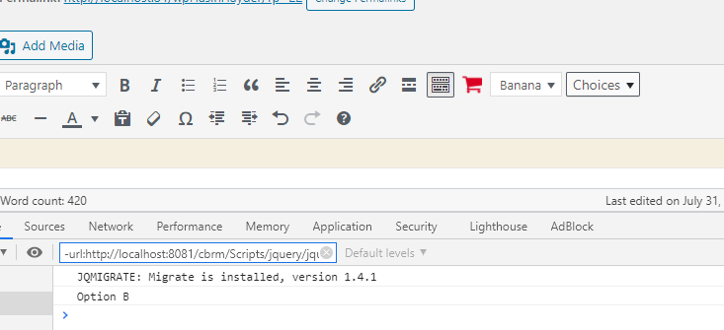

akta value click korla Output dekhaba

Akun amra multi level korta chai attar jonno amra oyi nothun editor.addButton jater 1st parameter hocha ‘tmcd_menu_one’ ottar menu keyword er shob onclick keyword r ter values gullo remove kora dibo. Akun 3 ta option ar jonno 3 ta menu keyword abar add korbo r attar value abar nothun array add korbo, jamon overall Option A code ta hoba :

{

text:"Option A",

menu:[

{

text:"Option A - 1",

onclick:function(){

console.log('Option A - 1');

}

},

{

text:"Option A - 2",

onclick:function(){

console.log('Option A - 2');

}

},

{

text:"Option A - 3",

onclick:function(){

console.log('Option A - 3');

}

}

]

},

Ayi jaba amra B r C dibo. Save kora amra browser check korbo akun Choice click kora Option B click kora Option B – 2 click kori tokhun console Option B -2 ta dekhaba.

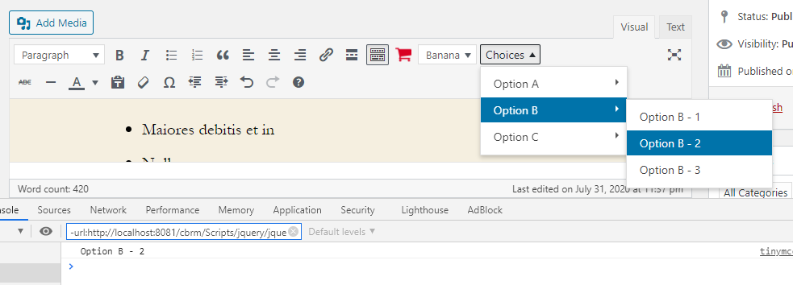

19.4

Ayi bar amra nothun akta button add korbo ar attata click korla amra akta form pop up korbo, jai form theka amra input nita parbo. Amra tinymce-demo.php ta giya tmcd_mce_buttons function body ta nothun value add korbo $buttons[] array ta ar oyi value ta hoba ‘tmcd_form_button’.Tarpor amra tinymce.js giya amra nothun editor.addButton add korbo r attar 1st parameter naam dibo ‘tmcd_form_button’ 2nd object literal hoba jar vitora amra text naam a keyword add korbo r ‘Form’ naam a value add korbo. Tarpor amra onclick keyword ta add korbo r value hisaba amra function pass korbo. R ayi function ar body ta amra open access korbo windowManager theka r atta access korbo editor theka. Ayi open() method, ()notation vitora amra object literal parameter hisaba add kori. Object literal vitora amra 1st keyword hoba title ar attar value hoba “User Input Form” tarpor body naam a keyword add kori ar akta array[] value hisaba pass kori. Ayi array ta nothun 2ta object literal add kori.

{

type:'textbox',

name:'userinput1',

label:'Some Text',

value:'hello'

},

{

type:'colorpicker',

name:'userinput2',

label:'Color',

value:'#222222'

}

Tai overall code hocha:

editor.addButton('tmcd_form_button',{

text:'Form',

onclick:function(){

editor.windowManager.open({

title:'User Input Form',

body:[

{

type:'textbox',

name:'userinput1',

label:'Some Text',

value:'hello'

},

{

type:'colorpicker',

name:'userinput2',

label:'Color',

value:'#222222'

}

]

});

}

});

Akun amra brower giya kono akta post edit button click kora oyi page a amra Visaul click korar por amra Form button dekta parbo.

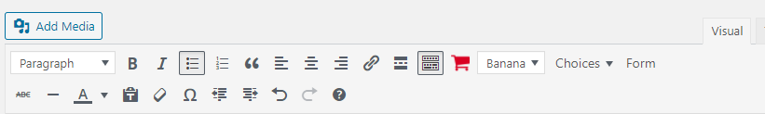

Tarpor oyi form click kora dekban ja atta asba

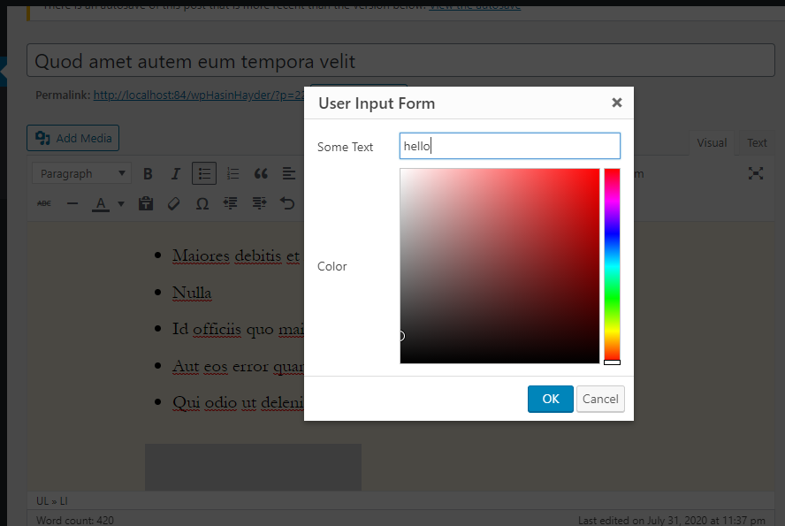

Akun amra on submission oppor kaj korbo jokhun ok click korba. To amra tinymce.js a giya amra open() method a amra object literal vitora amra onsubmit naam a nothun akta key add korbo ar attar value hishaba function() pass korbo. Amra jokhun OK click korbo browser tokhun ayi pura refference pabo akta event modha ar oyi event ka amra e naam diya oyi onsubmit ar function ar ()natation modha pass hoba. Diya oyi function body ta amra console.log(e.data.userinput1) dibo karon amra check korbo ja input value ta ja pass korsha userinput1 otta dekta. To akun Form button a click kora amra Some Text input diya Ok click kori taholla console a otta output hishaba dekhaba.

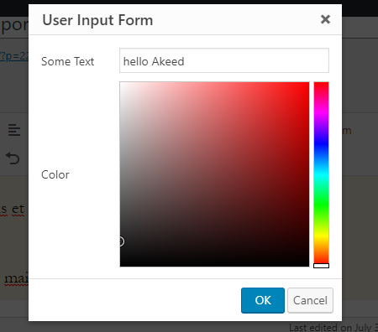

Akun console amra dekbo

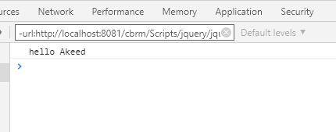

20

Watch the video

২০.১ - প্লাগইনের ভেতর থেকে কাস্টম পোস্ট টাইপের জন্য টেমপ্লেট ফাইল সেট করে দেয়া

Amra akta widget banabo. To amra Demo Widget naam a akta folder banabo ar vitora amra demowidget.php naam akta page banabo. Ar vitora amra ja ja header ache oyi shob add korbo. header code hoba:

<?php

/*

Plugin Name: Demo Widget

Plugin URI: https://learnwith.hasinhayder.com

Description: Demo Widget

Version: 1.0

Author: LWHH

Author URI: https://learnwith.hasinhayder.com

License: GPLv2 or later

Text Domain: demowidget

Domain Path: /languages/

*/

Jahuto onak takba widget a ayi jonno translation add korta hoba. To attar jonno amra aga add_action hook ta add korbo. Ar ()notation vitora amra $tag hisaba amra 'plugins_loaded' ar $function_to_add hoba 'demowidget_load_textdomain'. Tarpor amra ayi hook ar function ta banabo. Ayi function body ta amra akun amra load_plugin_textdomain function ta add korbo r $domain hisaba amra 'demowidget', $deprecated ka amra false dibo, $plugin_rel_path ka amra plugin_dir_path( __FILE__ )."languages/" . So overall code hoba:

<?php

/*

Plugin Name: Demo Widget

Plugin URI: https://learnwith.hasinhayder.com

Description: Demo Widget

Version: 1.0

Author: LWHH

Author URI: https://learnwith.hasinhayder.com

License: GPLv2 or later

Text Domain: demowidget

Domain Path: /languages/

*/

function demowidget_load_textdomain(){

load_plugin_textdomain('demowidget',false,plugin_dir_path( __FILE__ )."languages/");

}

add_action('plugins_loaded','demowidget_load_textdomain');

Akun amra akta widget banabo, widget hocha basically akta class so basically amrader widget ta OOP style likta hoba. R onak vhaba kora jai kintu better way banata holla amra akta nothun akta folder banabo r naam dibo widgets DemoWidget vitora r nothun akta file add korbo ar naam dibo class.demowidget.php

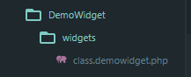

Amra oyi file a <?php opening tag dibo r class DemoWidget add korbo r amra extend WP_Widget, interface concept ayi case DemoWidget hoba derived class ar WP_Widget ta hocha base class. Class body akun amra akta __construct function add korbo ar Access_Identifer public hoba. Ayi function_body ta amra __construct function ta define korbo jeta parent class asba scope resolution operator diya. Ayi __construct ar ()notation vitora hoba $id_base hoba hoba ‘demowidget’, $widget_options hoba __(‘Demo Widget’, ‘demowidget’), r

$constrol_options hoba __(‘Our Widget Description’, ‘demowidget’). To overall code hoche:

public function __construct(){

parent::__construct(

'demowidget',

__('Demo Widget','demowidget'),

__('Our Widget Description', 'demowidget')

);

}

Bas amader ja bootstrapping ta dorker otta kora pellam. Amader 3 ta function lagba, 1st ta hocha widget function jeta hocha output dekhanor jonno responsible, 2nd ta hocha form function jeta hocha input nawar jonno responsible r 3rd hoba update jeta hocha data gullo save korar jonno. To amra step korlam function __construct theka r 3 function add korlam - function form(), function widget() r update(). Ayi shob 3 function ar Acces_Identifer hoba public. To overall code hoba:

public function form(){

}

public function widget(){

}

public function update(){

}

First ta amra form function ta niya kaj korbo ar ayi function ar ()notation modha amra $instance add korbo parameter hisaba. Ayi $instance ta akta object hishaba kaj korba. Amra akun amra function_body ta ternary operator diya amra isset($instance[‘title’]) ka amra expression nillam, jodi null na hoy taholla true hoy r amra $instance[‘title’] ka amra 1st statement hisaba resultant value hoba r null hoy taholla false hisaba amra __(‘Demo Widget’, ‘demowidget’) atta 2nd statemnt hisaba resultant value hoba. Akun ayi argument ta amra assign korbo $title variable. Next step amra akun form dekhabo, attar jonno amra php closing tag r open tag dibo. Ayi 2 tag vitora amra html code add korbo. Amra paragraph opening r closing tag dibo. R ayi 2 tag ar vitora amra content hishaba amra label ar opening r close tag add korbo ar por amra input tag add korbo. label opening tag a amra for attribute add korbo r ar value hisaba amra akta statement dibo. Ayi statement ta hoba:

<?php echo esc_attr($this->get_field_id(‘title’));?>

Note: wordpres amra jokhun widget likbo ar jonno id directly leekta parbo na, attar jonno wordpress jai id disha shetta amra diboni. Shettar jonno function otta hocha

Akun ayi label ar opening r closing tag ar majha amra <?php _e('Title','demowidget')?> add korbo content hisaba . Akun amra input tag id attribute add korbo r ar value hishaba amra <?php echo esc_attr($this->get_field_id(‘title’));?>. Amra 2nd attribute add korbo r naam dibo name ar value hisaba amra <?php echo esc_attr($this->get_field_name('title'));?> . Amra value add korbo 3rd attribute hisaba r ayi attribute ar value hoba <?php echo esc_attr($title); ?> . So overall code hoche:

public function form($instance){

$title = isset($instance['title']?$instance['title']:__('Demo Widget','demowidget'));

?>

<p>

<label for="<?php echo esc_attr($this->get_field_id('title'));?>"><?php _e('Title','demowidget')?> </label>

<input type="text" id="<?php echo esc_attr( $this->get_field_id( 'title' ) ); ?>" name="<?php echo esc_attr($this->get_field_name('title'));?>" value="<?php echo esc_attr($title);?>">

</p>

<?php

}

Tarpor amra demowidget.php ta giya akta action hook add korbo. Ayi hook ar $tag hisaba amra widgets_init add korbo r $function_to_add a amra demowidget_register set korbo. Tarpor amra demo_widget_register function ta banabo. Ayi function body ta amra register_widget(‘DemoWidget’); set korbo. Atta amra korchi karon amra cabo ja DemoWidget class ta register hok. Akun amra class jai file ta otta amra set korbo demowidget.php ta . So amra browser giya ayi plugin ta activate kori kintu tokun amra activate kora dekbo ja akta error asche:

Attar solution akun kar jonno hocha class.demowidget.php giya widget r update function ta comment korta karon attar konno kaj nai akun kar jonno.

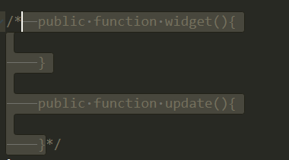

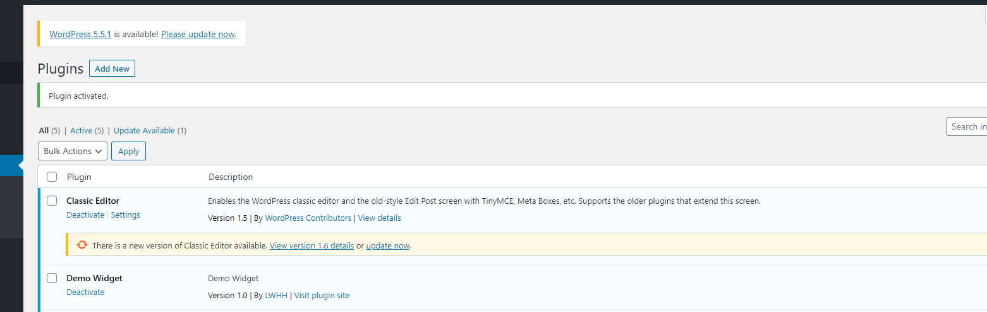Akun activate korla thik ashba

PTO

Akun amra Appreance ta click kora Widget click korar por amra amader Demo Widget dekta parbo.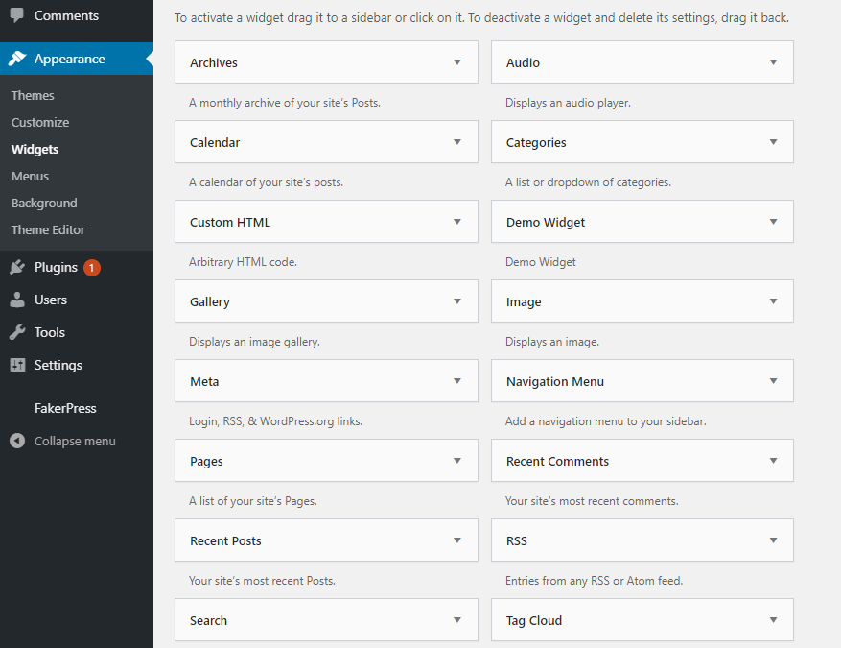

Akun amra ayi widget ta drag kora Footer #2 niya niya asta parbo



Akun jodi apni chan input ta pura cover korta taholla amra class.demowidget.php ta giya amra giya input tag vitora amra class attribute add kori r attar value hisaba amra widefat

PTO

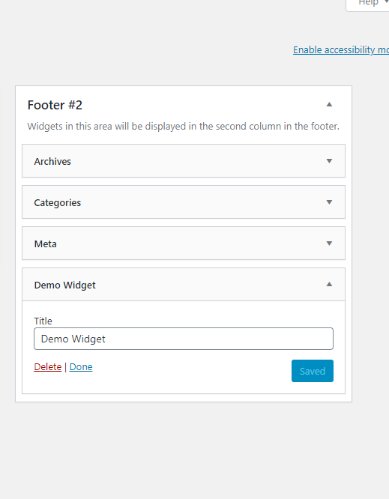

Akun amra latitude input field anbo. Tai amra class.widget.php ta giya amra $latitude assign korbo:

$latitude = isset($instance['latitude']) ?$instance['lattitude']: 23.9;

Tarpor amra html short code add korbo jai vhaba amra $title ar shortcode add korchi:

<p>

<label for="<?php echo esc_attr($this->get_field_id('latitude'));?>">

<?php _e('Latitude','demowidget')?> </label>

<input type="text" class="widefat" id="<?php echo esc_attr( $this->get_field_id( 'latitude' ) ); ?>" name="<?php echo esc_attr($this->get_field_name('latitude'));?>" value="<?php echo esc_attr($latitude);?>">

</p>

Akun amra browser a giya check kora dekbo ja lattitude asche

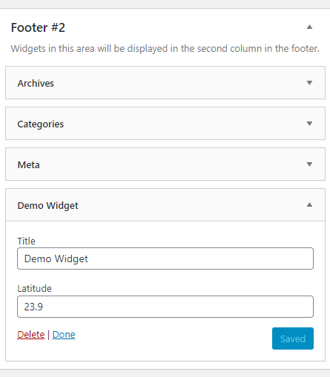

Widget data gullo amra add kora automatically save korsha wordpress. Akun same way ta amra abar logitude ar jonno text field set korbo, to agar motto amra $longitude variable assign korbo r html shortcode likbo.

longitude input text field add korbo widget a attar jonno amra 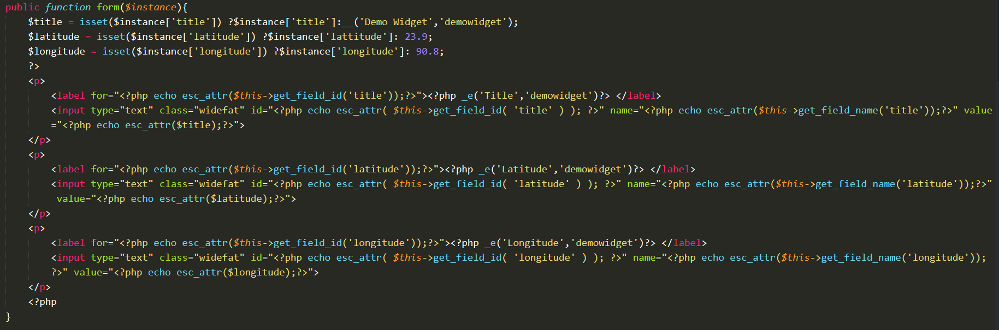

Akun browser a giya amra check korlam ja longitude ache.

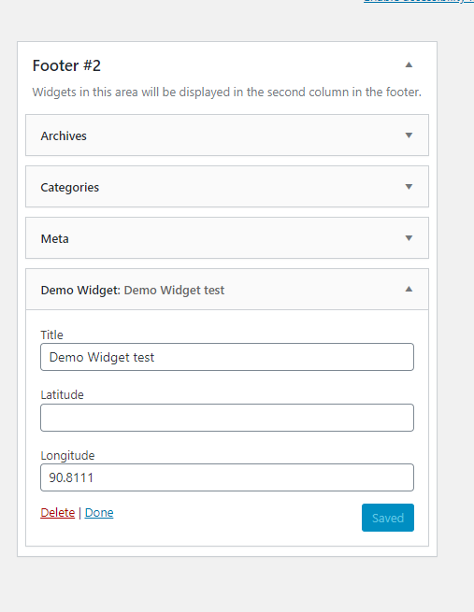

Akun amra output display korbo. Atta jonno amra widget function ta comment out korlam ar ()notation vitora amra $args ar $instance parameter hisaba nichi. $args ta hocha internal data gullo ditta hoba jokhun side bar ta register kora hoysha, tokun jai sidebar a widget ta dekhache shai sidebar ar before widget r after widget kon tag gullo dawa chillo oyi jinish gullo ar vitor theka. R $instance vitora theka shob value gullo.function body ta amra 1st step hisaba amra echo $args['before_widget']; 2nd step a amra if condition ta dibbo, ayi if condition boolean expression check korba ja $instance ar title value ta ki null naki empty attar jonno amra isset($instance['title']) && $instance['title'] !='' dillam boolean expression hisaba akun jodi condition ta true hoy taholla 1st statement hisaba amra echo $args['before_title']; dibo . 2nd statement a echo apply_filters('widget_title',$instance['title']); dibo. 3rd statement hoba echo $args['after_title']; . Porar statement a amra php closing tag ?> add kora amra next line theka amra html shortcode add korbo. So amra akta div tag nibo . R opening tag ar vitora class naam a akta attribute add korbo r value hisaba demowidget add korbo. content a amra paragraph tag add korbo. Ayi tag content a amra Latittude: <?php echo isset($instance['latitude']) ? $instance['latitude']:'N/A';?> amra dibo. Akun Longitude ar jonno amra same vhaba paragrph tag nillam ar ottar content o same vhaba set korlam. Tarpor amra div closing tag theka step out korbo, tarpor php opening tag theka ber hobo abong if condition theka ber hoya jabo finally amra echo $args['after_widget']; last step diya function widget ar function_body kaj shesh korbo.

Amara footer one giya Demo Widget a Title, Latitude r Longitude add kora Save korbo.

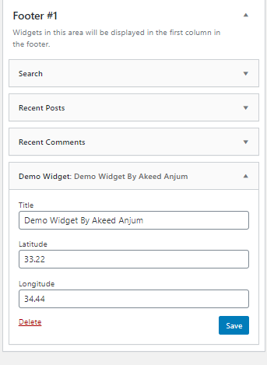

Tarpor amra Visit Site a giya click kora main website a giya

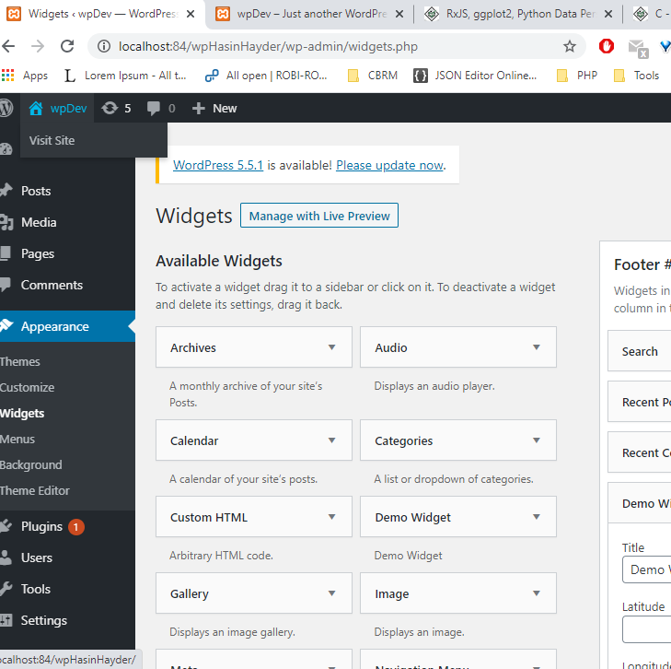

Akana click kora check korbo

website a giya amra

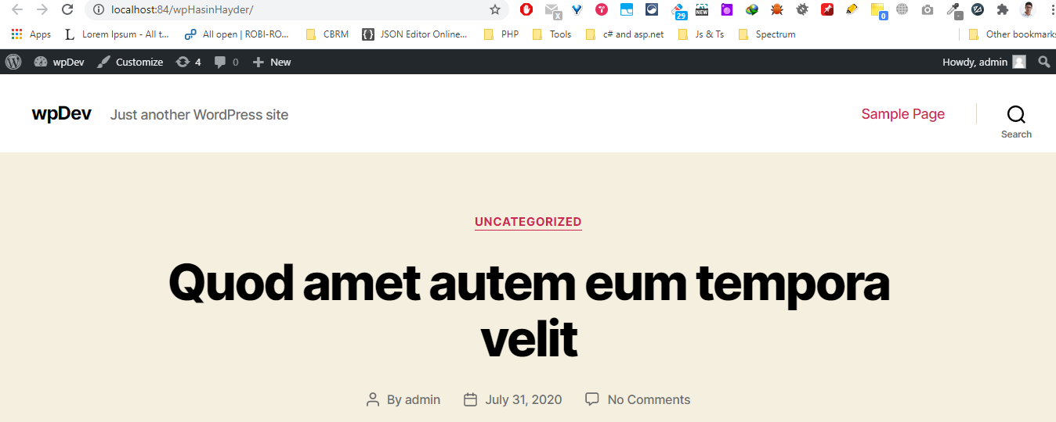

Nicha footer giya amra pabo

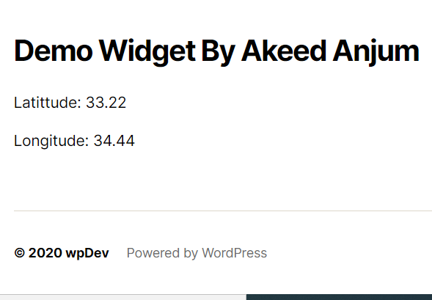

Note:

Ami jodi print_r($instance) di widget function ar function_body ta taholla $instance shob output dekta parbo. Example:

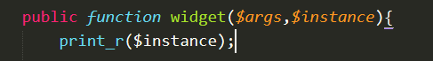

Akun jodi website a jai, taholla amra oyi $instance ar output ayi khanna dekta parbo

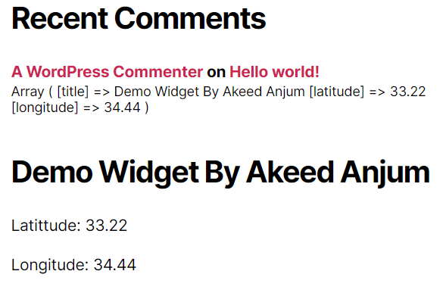

Akun amra jodi widget nicha description dekta chai taholla amra

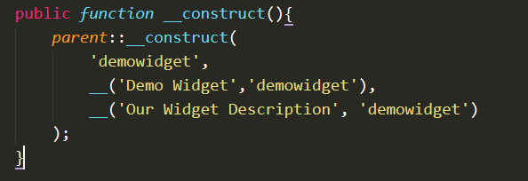

change kora



Ayi bar widget amra description ta dekta parbo browswer a

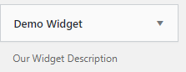

21-2

Amra akun client side theka jotto validation dawar otta set korbo, jamon

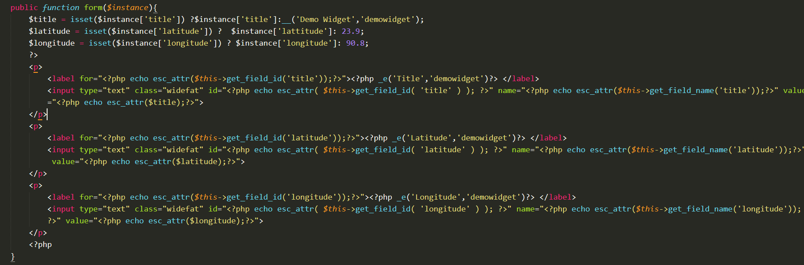function form ar function_body t amra <p> ar vitora input tag ar type attribute ar value text theka number korboni .



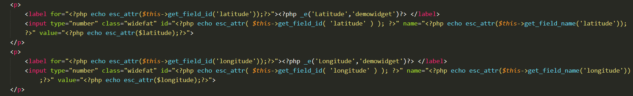

Taholla number chara onno konno kichu input hoba na input field a . Tarpor amra email field ar jonno amra kichu code add korbo, aga amra assignment expression diya amra $email variable ka assign korbo ar oyi assignment expression ta hoche:



Tarpor title, latitude r longitude jai vhaba amra html code ta set korshi oyi vhaba amra email ar o code ta set korbo

Akhun amra jodi browser a giya dekhi, taholla shob dekta parbo

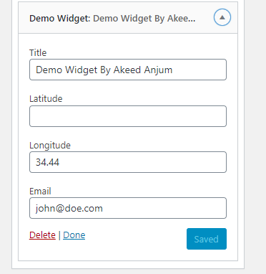

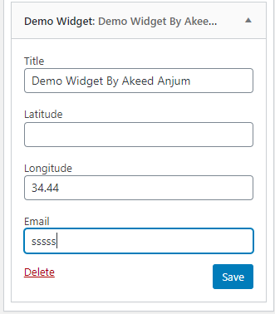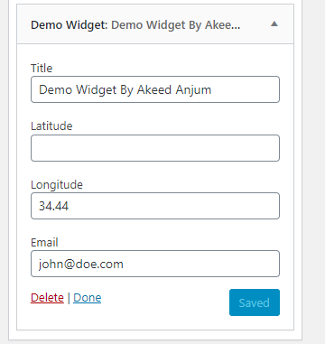Ayi shob ja kaj korlam ayi shob hoche client side a validation . Akun amra server side validation dekbo. R attar jonno amra update function ta comment out korbo. Tarpor amra oyi function ar () notation vitora 2ta parameters nillam, 1st parameter hoba $new_instance, r 2nd parameter hoba $new_instance['email'] expression ta assign korbo $email variable ka. Then next step a amra if condition diboni , r boolen expression a amra dibo !is_email($email) . If condition ar vitora amra statement hisaba amra dichi return $new_instance; Tarpor amra if condition theka step out kora amra return $old_instance; dillam. Akun jodi amra check kori

change kori

Save ar porao Still agar ta dekha che



Note:

if condtion a is_email ta formatting.php theka asche. R according to mentor, formatting.php onak onak dorkari function dawa ache.

Akun amra onno vhaba validation korbo, ayta aro better according to the mentor [ayi video ta](https://youtu.be/QTGlw7AIqFI) .

Attar jonno amra function update ar function_body ta amra

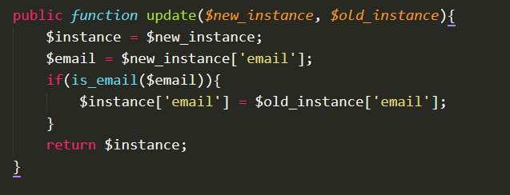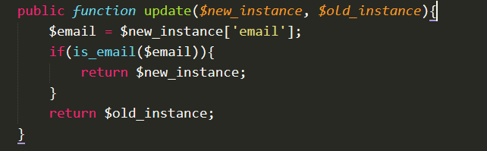

change to

chato

add a new instance

Ayi shob korar advantage hoche jodi email ta email dai taholla email ta chara shob save hoba . Tapor amra title, lattitude r longitude ar jonno validation set korchi.

PTO

So Amra

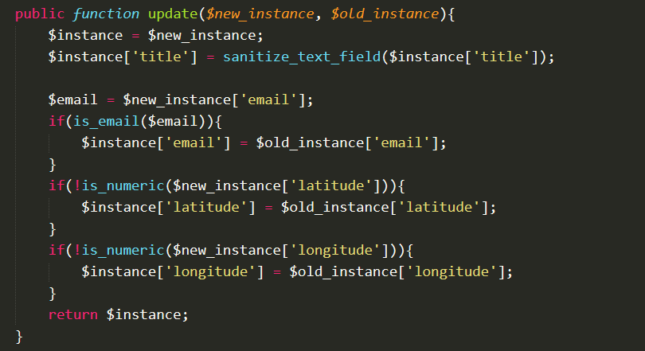

Amra title ta ka Sanitize korbo karon Sanitization is the process of cleaning or filtering your input data.

Amra check korbo latitude r longitude ta ki numeric ki na attar jonno amra is_numeric use korbo karon is_numeric — Finds whether a variable is a number or a numeric string

Akun jodi amra dekhi [ayi video moto hoba](https://youtu.be/MSWHyO6AhMQ).

**The End of 21-2**

21.3

Ayi chapter a amra widget ar vitora amra kivaba amra media attach korta pari otta dekbo . Tai according to the mentor amra akun 2 ta file add korbo ayi shob directory ta.

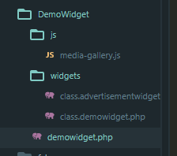

Amra widgets folder a giya amra class.advertisementwidget.php add kori

Amra DemoWidget a js folder a media-gallery.js diya di

Tarpor amra demowidget.php a ta giya amra ayi shob line of codes add korta hoba amader widget ta wp set korar jonno. Agar code chillo atta

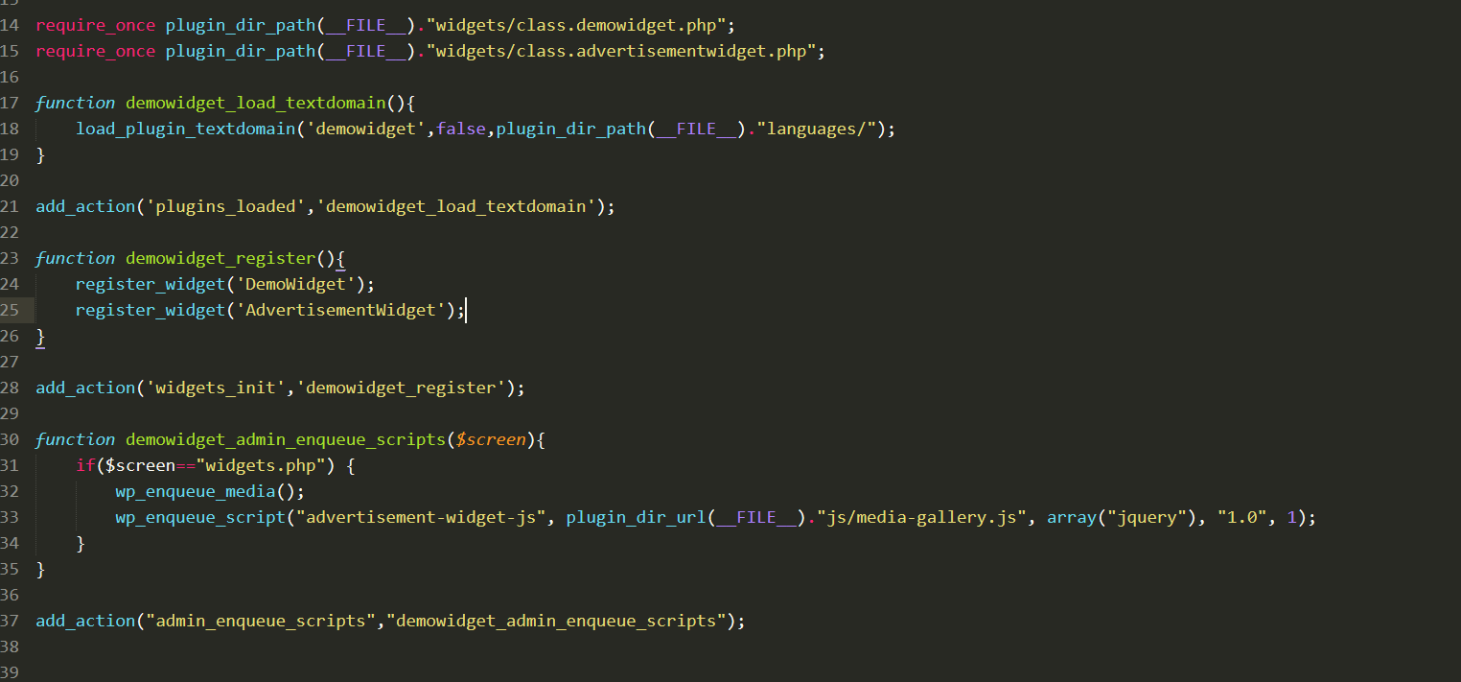

Adding the required code for media-gallery.js path

Adding the path of php

add_action hook diya amra for the script

Amra ayi shob korchi karon according to the mentor jeta ayi video dekhasa

[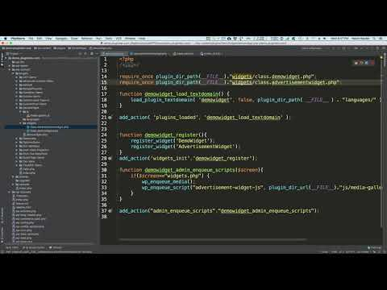](https://www.youtube.com/watch?v=SyrKTYsibNc)

Tarpor mentor class.advertisementwidget.php ta bujhaisha ayi video ta [wp_21_3_2](https://youtu.be/FDqntnO8GeM)

[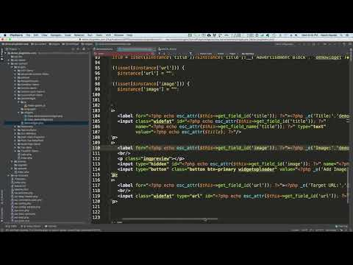](https://www.youtube.com/watch?v=FDqntnO8GeM)

Tarpor mentor amader ka media-gallery.js dekhaisha ar ki vhaba ayi widget ta kaj kora otta dekhasha ayi [wp_21_3_3](https://youtu.be/Ew3AXdq-ygY)

[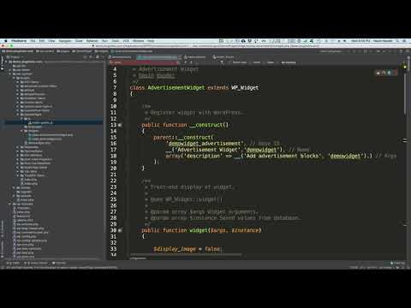](https://www.youtube.com/watch?v=Ew3AXdq-ygY)

**The End**

**21- 4**

Otta video dekla hoba

**21-5**

Amra akun mentor ar onnu jai amra kaj ta korbo [wp21-5-1](https://youtu.be/K7NgmdIyQMw)

[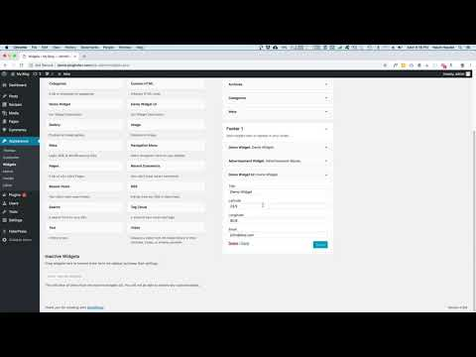](https://www.youtube.com/watch?v=K7NgmdIyQMw)

To amra akhun akta nothun php file banabo ar naam ta hoba class.demowidgetui.php ar atta ayi path a hoba. Tarpor amra class naam ta change kora DemoWidgetUI naam dishi ar __construct() ar vitora amra demowidget propertry change kora demowidgetui korta hoba.

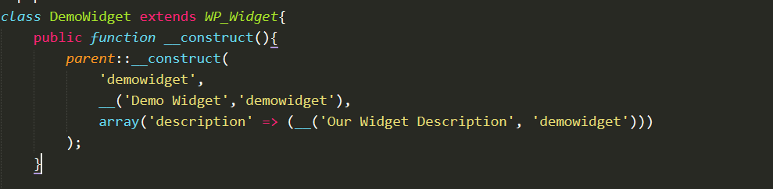

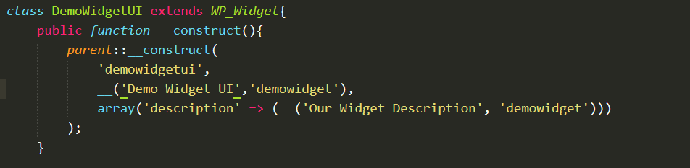

Tarpor amra demwidget.php i.e amader plugin a amra jabo. Tarpor nothun akta require_once add korbo demowidgetui plugin directory path ar jonno



Tarpor amra demowidget_register function body ta amra DemoWidgetUI ar register_widget function add korbo.



demowidget_admin_enqueue_scripts a function_body ta amra wp_enqueue_style ta add kori r attar $handler hisha ba amra "demowidget-admin-ui-css" r $src hishaba amra plugin_dir_url(__FILE__)."css/widget.css" . To overall code hocha



Amra tarpor akta folder banai DemoWidget ta, r naam di css r atta vitora amra akta file banai r ottar naam di widget.css, jamon:

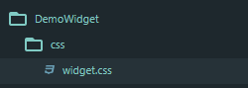

Tarpor ayi widget.css file a vitora amra ayi code ta di

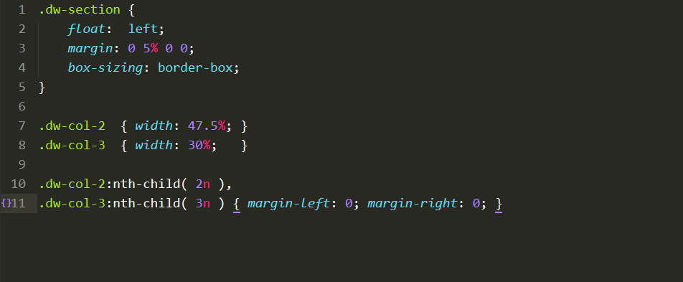

Amra css a file ayi code dishi karon according to the mentor ayi [wp25-5-2](https://youtu.be/q13jUAknbXI) video ta.

Tarpor amra div nibo r class ar naam akta attribute dibo dw-section r dw-col-2 value set korbo.

Ayi div content a amra agar 2 <p> tag r otter content soho okhana place korbo. Tarpor oyi div ta copy kora nothun kora paste korbo r baki oyi <p> tag ta cut koraniya, ayi nothun div ar modha paste kora boshabo. Akun amra browser a giya dekhi akun Demo wigdet UI change hoysha

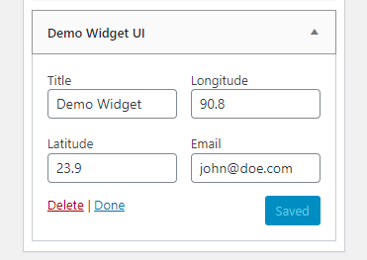

Akun jodi amra atta 3 colomn dittam taholla amra ayi video ta [wp-21-5-3](https://youtu.be/yjW8NxwQC4M)

Tarpor akun jodi kono html tag jamon 2 ta <p> tag bahira rakhe taholla browseer a ayi rokhun hoba

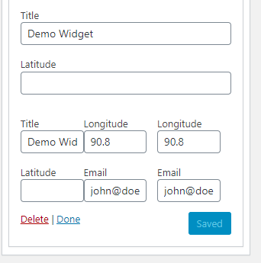

R ayi shob ar jonno shob code hoba:



Akun amra akta tab anta chai attar jonno amra ayi html code ta add korta hoba otta ayi file a ache



Note: ja ayi tab ar jonno jai div ta nishi ottar class attribute value ta wordpress built-in class use kroshi wp-tab-panel.

Tarpor browser dekba ja

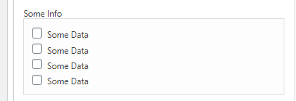

**THE END**

21-6

Amader piklist naam a akta plugin install korta hoba attar jonno amra browser a giya amra ayi link a giya <https://piklist.com/> amra Piklist download korbo. Tarpor oyi plugin ta install kora active korbo.

Tarpor amra PiklistDemo naam akta folder banabo plugins folder vitora oyi folder a amra piklistdemo.php . Tarpor amra plugin description add korbo. Note: ayi plugin description ar jonno amra nothun akta line add korri otta hocha atta Baki shob agar motto.

Akun amra Piklist site giya ottar documentation dekha amra akata folder banabo r naam hoba parts r ar vitora r akta nothun folder hoba r ottar naam hoba widgets. Oyi widgets folder a amra 2ta files add korbo demowidget.php r demowidget-form.php

তারপর আমরা piklist documentation এ গিয়ে আমরা widgetয়াই ।

তারপর আমরা view tutorials এ যাব ওখানে আমরা ক্লিক তিপে আমরা easy widget দাকব, আবার ওটা ক্লিক করে দেকব যে widget যত fields লাগবে তত ঐ ভাবে দিতে হবে

PTO

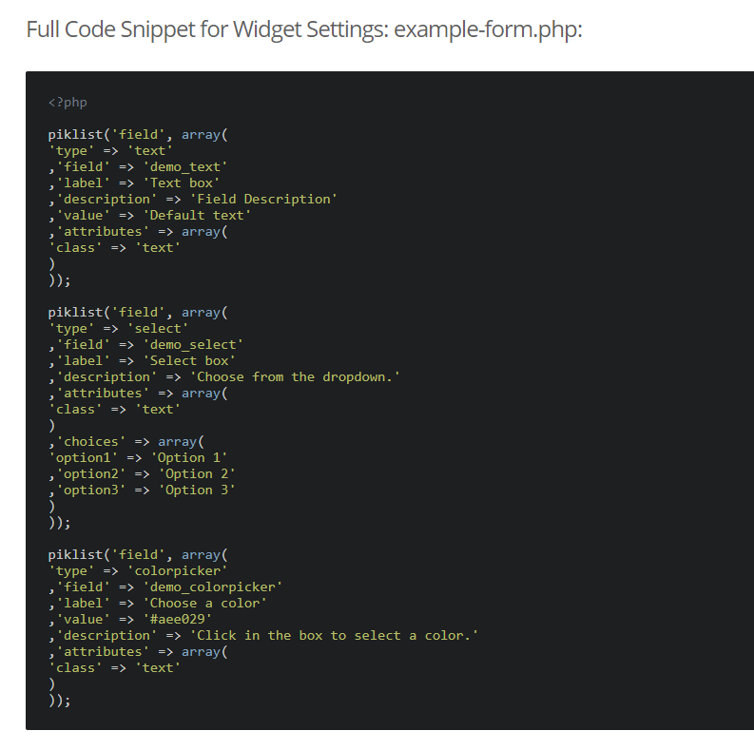

এটা আমরা demo-widget-form.php কোড এ পেস্ট করি। এদের কোড লেখা স্টাইল আমাদের কোডের স্টাইল নিয়ে আনতে হবে, তাই আমরা কোড ctrl+H প্রেস করে আমরা \n, find এ দিয়ে তারপর আমরা alt+r প্রেস করে আমরা Replace এ আমরা ,\n ক্লিক করব ।

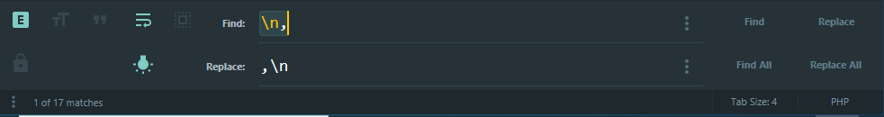

যত hardcoded strings আছে ওই সব কে translate করতে হবে । এখুন আমরা demowidget.php কে আমরা output file হিসাবে রাকব তাই আমরা এখুন কার জন্য আমরা এই কোড তা অ্যাড করব

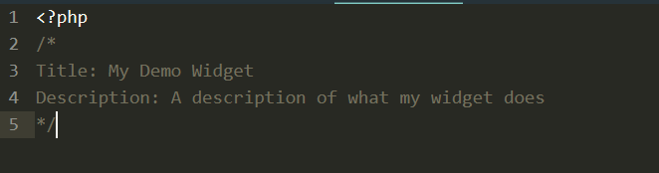

তারপর আমরা installed Plugins page এ গিয়ে আমরা DemoPiklist টা এক্টিভেট করব ।

এখুন আমরা browser এ Appreance 🡪widget গিয়ে আমরা আমাদের DemoPiklist Widgets টা দেখতে পারব ।

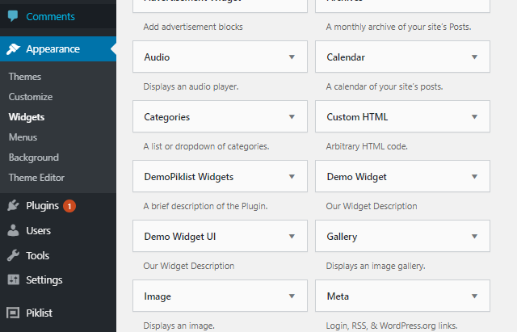

Note: According to the mentor

[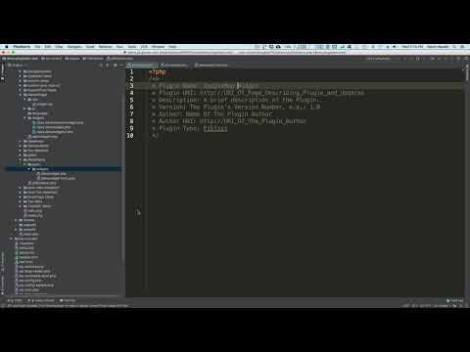](https://www.youtube.com/watch?v=7GmFRLCsoPo)

এখুন আমরা footer #1 আমদের DemoPiklist Widgets টা অ্যাড কোরেছি ।

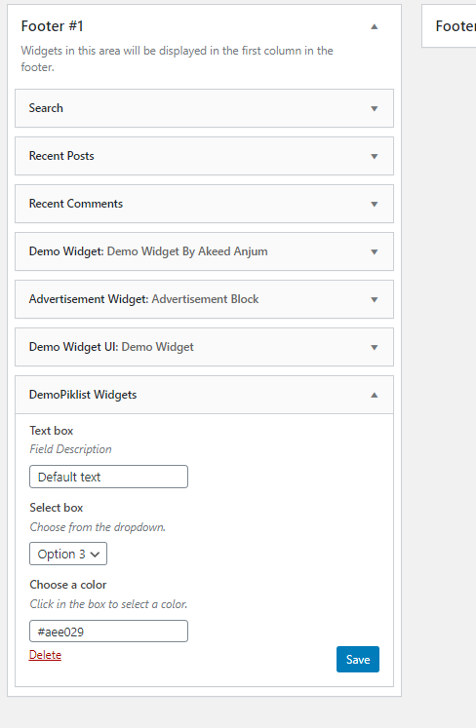

এখুন যদি আউটপুট দেখতে চাই এটার জন্য আমরা আগে :-

piklist site এ গিয়ে Documentation🡪widgets🡪easy-widgets এ গিয়ে আমরা Widget Output File সেকশন এ পার্ট কপি করব

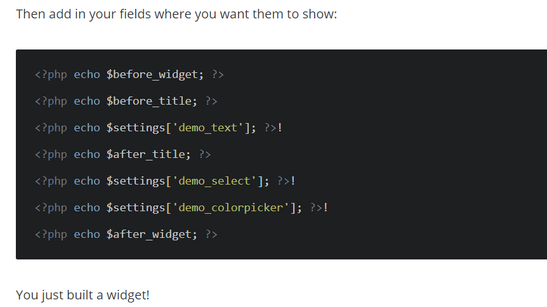

এইটা কপি করে demowidget.php এ পেস্ট করব । এখুন আমরা browser এ গিয়ে আউটপুটা দেখি

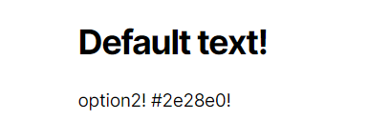

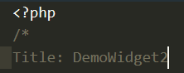এখন আমরা যদি ২ widget বানাই তাহলে আমরা demowidget.php আর demowidget-form.php ডুপ্লিকেট করে আমরা একি widget ফোল্ডার এ পেস্ট করব আর নাম দিবো demowidget2.php আর demowidget2-form.php । আর Title এ আমরা দিবো DemoWidget1 আর DemoWidget2

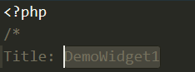

আমরা demowidget2-form.php, colorpicker টা ফেলেদি

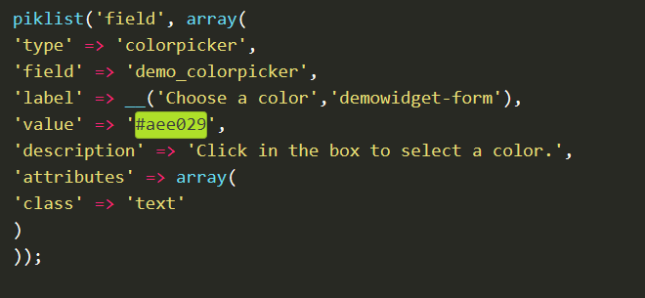

আর 2টি field এর নাম চেঞ্জ করে দিবো ।







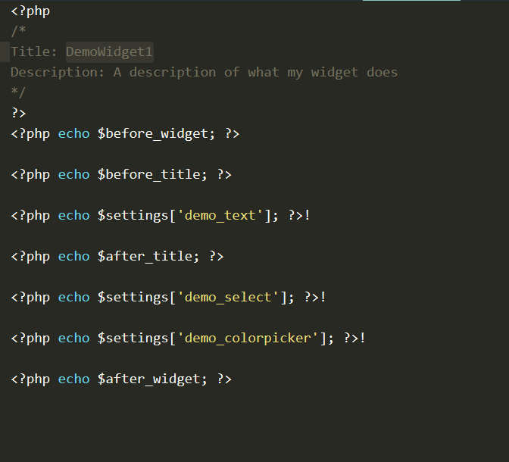তারপর আমরা demowidget2.php তে গিয়ে কোড চেঞ্জ করব

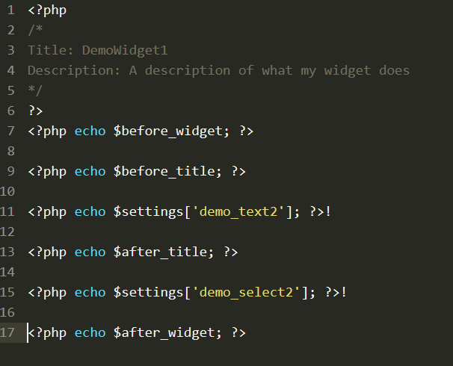

change

change

Removed

এখুন আমরা browser গিয়ে দেখি

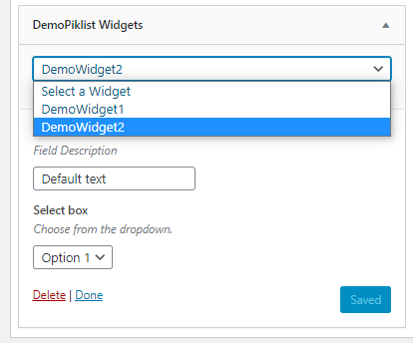

এখুন আমরা google map widget বানাবনি, তোই আমরা demowigdet2.php কে একি জয়গাই ডুপ্লিকেট করে নাম দিবো googlemap.php আর একাই demowigdet2-form.php ভাবে ডুপ্লিকেট করে নাম দিবো । দিয়ে আমরা googlemap-form.php তে গিয়ে আমরা এই কোড অ্যাড করব

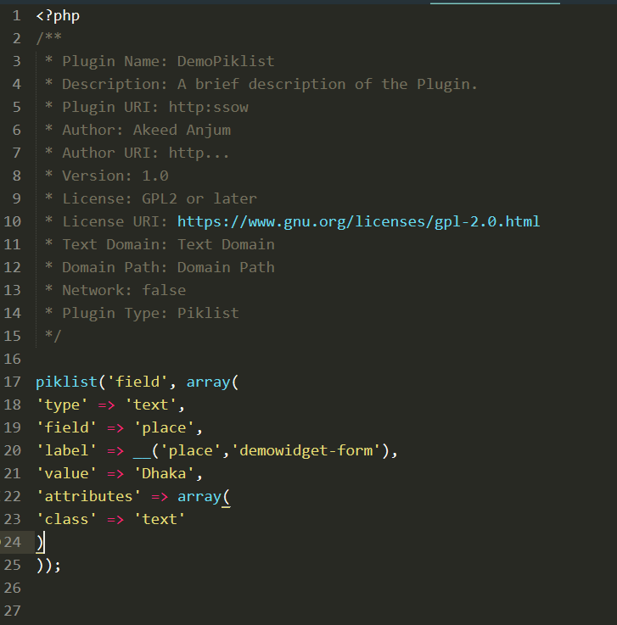

তারপর আমরা googlemap.php তে গিয়ে এই কোড অ্যাড করি

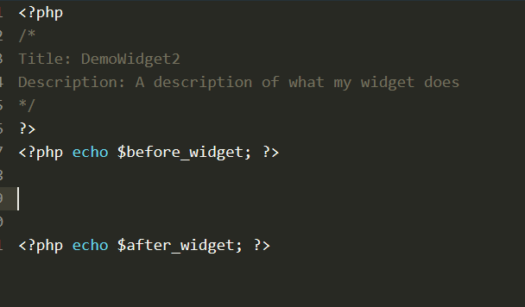

তারপর আমরা <http://www.embedgooglemap.net/> লিঙ্ক কে গিয়ে

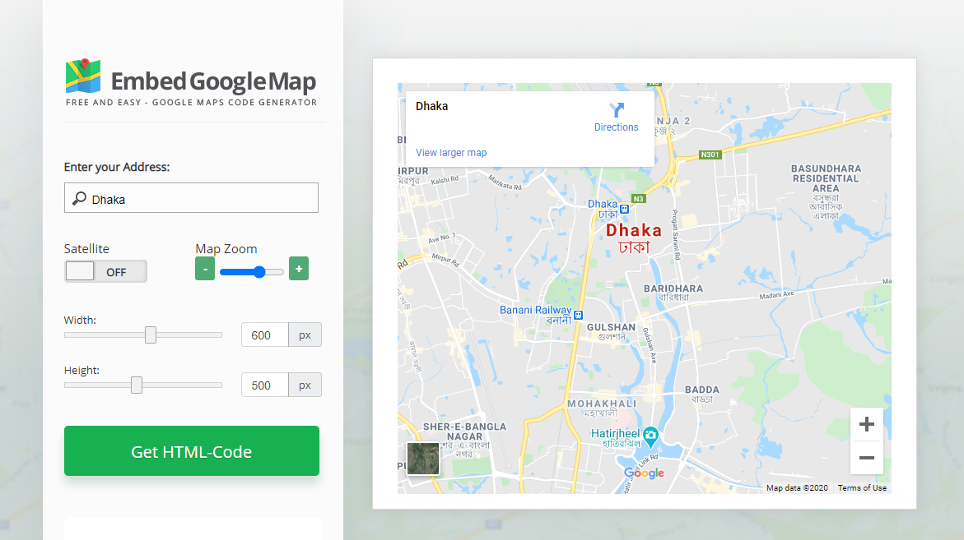

আমরা Dhaka টেক্সট ফিল্ড অ্যাড করি । তারপর আমরা এই বাটন ক্লিক করে কোড কপি করি । তারপর আমরা googlemap.php তে গিয়ে আমদের কোড পরিবর্তন করি ।

আমরা এই কোডটা পরিবর্তন করব



এই কোড এর সঙ্গে



তারপর আমরা browser এ গিয়ে আমাদের googlemap widget টা অ্যাড করব

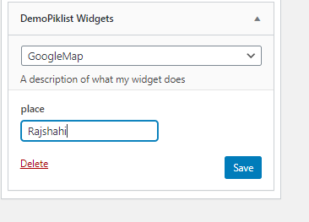

এখুন আমরা মূল পেজ এ গিয়ে দেখব

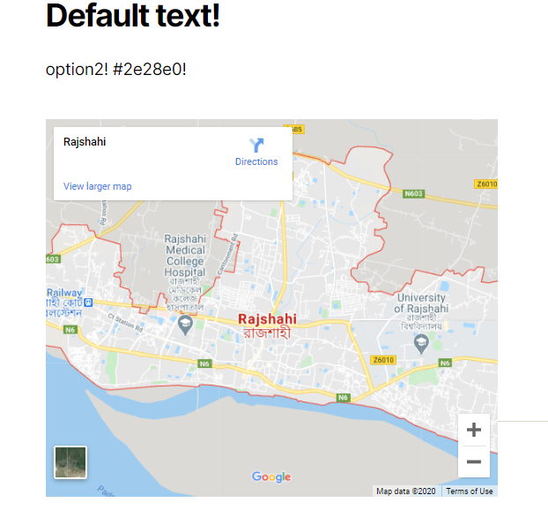

|  |  |
| --- | --- |
|  |  |
| Adding code when describing | echo $args['after_widget']; |
| Writing first time variable/parameter | $args |
| Writing overall code | <label for="Hello">HI</label> |
| Error/Note | Error: |
| Class | ClassName |
| Method | MethodName |
| File name | File.php |